

**Technical Report**

|  |
| --- |
| **No.1 Wind Turbines** |

Excel

* Renaming of columns - refer to Data Dictionary

Python

* Handling nulls and removing columns – refer to Data Dictionary; and Juypter Notebook for code
* Assumption – based on data distribution, we have applied
* mean value to t_rsa (7618.5); and
* median values to p_cap (158.0), t_cap (2000), t_hh (80.0), t_rd (100.0) and t_ttlh (130.1).

Tableau

* Join with EIA Operators (“Cleaned_EIA.csv”) using with eia_id -> eia_id
* Join with “Wind_Speed_Data.xlsx” using t_state -> state_name

|  |
| --- |
| **No.2 EIA Operators** |

Python

* Handling nulls and removing columns – refer to Data Dictionary; and Juypter Notebook for code
* Assumption – The number of Operators was reduced (story 02) by including only Operators with > 10 data points.

Tableau

* Join with “Cleaned_Windturbine.csv” using with eia_id -> eia_id

|  |
| --- |
| **No.3 Wind Speed** |

A third dataset was used to represent average wind speeds by US State.

Excel

* Excel was used to insert wrangle data to include US State abbreviation and match with **Wind Turbines.**

Tableau

* Join with “Wind_Speed_Data.xlsx” using state_name -> t_state

|  |
| --- |
| **Sample Analysis of Wind Turbine and Operator datasets using Python** |

**Size of dataframe -** Windturbine

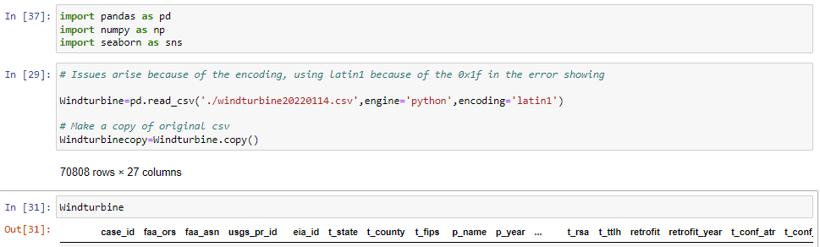

**Identifying nulls -** Windturbine

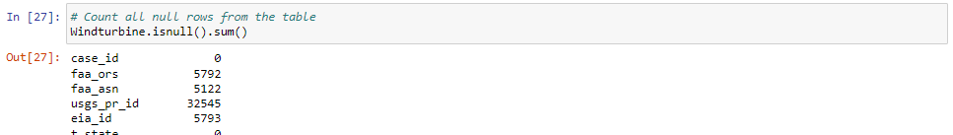

**Descriptive statistics -** Windturbine

|  |  |
| --- | --- |
|  |  |

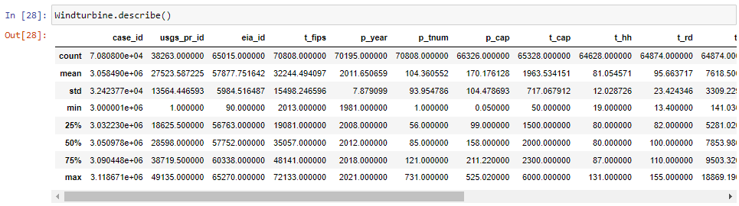

**Size of dataframe -** CleanforGenerationandFuelData

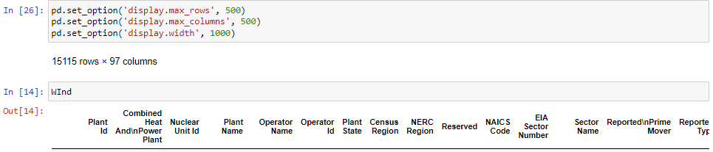

**Identifying nulls -** CleanforGenerationandFuelData

